Академия логистики и транспорта |  | Логистика және көлік академиясы

INFORMATION LETTER

DEAR COLLEAGUES!

April 28, 2023 Academy of Logistics and Transport holds the traditional III International Conference "Innovative technologies in transport: education, science, production" for teachers, young scientists, PhD students, undergraduates and students of universities.

The main areas of the conference (sections):
- Automobiles and road engineering;
- Topical issues of social and human sciences and physical education;
- Actual problems of digital systems development in transport;
- Actual problems of Construction Engineering;
- Innovative technologies in logistics;
- Natural science disciplines;
- Innovations in transportation process;
- Problems and prospects of development of telecommunication systems;
- Design, operation and repair of railway rolling stock;
- Innovative priorities in the process of teaching languages;
- Digital technologies in electric power industry.

The working languages of the conference are Kazakh, Russian, and English.
Papers submitted to the conference should contain the results of relevant scientific research or be of important practical importance. The best reports of full-time students will be awarded diplomas of ALT and included in the Proceedings of the conference based on the decision of the Organizing Committee.
Form of participation in the conference - full-time / correspondence.
By results of conference will be published the collection of conference materials, included in EEB with assignment of the international number ISBN.

The final deadline for submitting reports and registration forms is 15.04.2022.

To participate in the conference, you must submit on paper and electronic media to the address of the Organizing Committee of the conference: isc@alt.edu.kz with the obligatory indication in the subject of the letter to the "III International Conference" the following materials:
- application for participation according to Appendix 1 (the file name must correspond to the surname of the first author);
- an article designed according to Appendix 2 (in the name of the attached file, specify: the surname of the first author of the title of the article);
- payment receipt.
The cost of publishing one article for authors with obtaining an electronic version of the collection is 5 000 tenge.

REQUISITES:

Joint Stock Company "Academy of Logistics and Transport"

97, Shevchenko str.

BIN 010740000551, KBE: 17

Account number KZ6184901KZ503555000 in Nurbank JSC

БИK NURSKZKX

VAT series 60001 No. 1218806 dated 27.01.2021

or example:

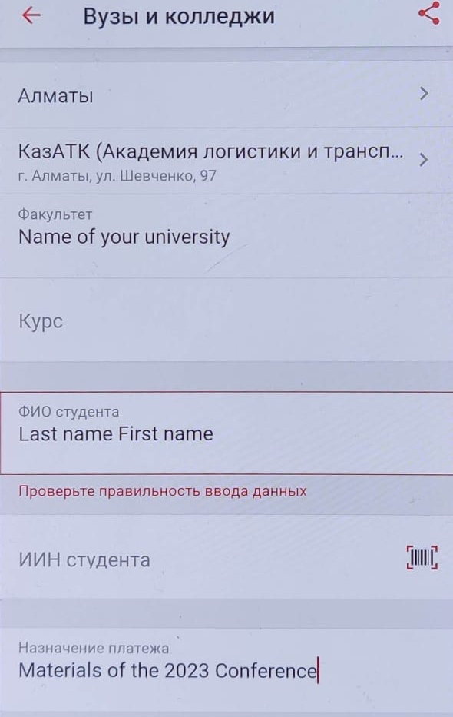

Expenses related to arrival at the conference, hotel accommodation are carried out at the expense of the participants or the sending party.
Foreign participants have the right to free publication in the proceedings.
All materials must be designed in accordance with the requirements and carefully edited. Materials that do not meet the requirements and submitted later than the deadline are not considered and are not sent back. The Organizing Committee reserves the right to select reports for inclusion in the proceedings.

ADDRESS OF THE CONFERENCE ORGANIZING COMMITTEE: 050012, Republic of Kazakhstan, Almaty, 97 Shevchenko str., ALT, office 2609. Phone: +7 (727) 346-10-74. E- mail: dn@alt.edu.kz .

Information about the III International Conference is available on the website: www.alt.edu.kz

ORGANIZING COMMITTEE

